A Rural Cancer Atlas for the UCSF Helen Diller Family Comprehensive Cancer Center

Debby Oh, Ph.D., Serge Atherwood, Ph.D., Scarlett Gomez, Ph.D.
Department of Epidemiology and Biostatistics
University of California, San Francisco

- Introduction

Rural populations in the U.S. have different cancer rates and patterns than populations in urban areas.^{1,2–4} Rural areas often show lower incidence rates for breast and prostate cancers but also higher rates for lung and colorectal cancers ^{1,5,6} and higher cancer mortality-to-incidence ratios overall.^{7,8} Overall cancer mortality rates continue to trend higher in rural versus urban counties across the U.S, a disparity noted by Acting NCI Director Dr. Doug Lowy as a federal research priority. In rural areas, lung cancer mortality is 54.0 per 1000,000 and colorectal cancer mortality (excluding appendix) is 34.6 per 100,000. In urban areas, lung cancer mortality is 40.9 per 100,000 and colorectal cancer mortality (excluding appendix) is 30.5 per 100,000.⁹

Due to heterogenous demographic and geographic characteristics in rural areas, cancer risk can vary across regions.^{10,11} Rural areas have lower population densities, which tends to result in fewer services and amenities and longer average distances to reach them. Furthermore, these areas also contain land use typologies (e.g., agriculture, mining) with environmental or occupational hazards that may increase the risk of health conditions, including certain cancers.

However, there is no clear consensus about what distinguishes an urban area from a rural one. In a geographically and demographically diverse place like California, this is especially true. In this report, we use two definitions of rurality to characterize the UCSF Helen Diller Family Comprehensive Cancer Center (HDFCCC) 25-county catchment area to explore cancer incidence, stage, and survival by rurality defined at the census tract level. The goal of this Rural Atlas is to help Cancer Center members better understand the epidemiological differences in cancer by different definitions of rural status and ultimately improve outreach and intervention efforts aimed toward rural populations.

- Defining Rurality

Rurality has long been acknowledged as challenging to define.^{12,13} The population density and urban characteristics such as San Francisco or San Jose are quite unlike those of the dispersed homesteads of the mountainous northern California forests or the vast agricultural landscapes of the Central Valley. But between these two extremes exists a diverse range of development patterns and land uses. Binary concepts of rurality may risk oversimplifying the complexities of the way land is used and variation in population density within large geographies that would be conventionally called rural. For example, a compactly developed city within a sparsely populated county would certainly be considered urban, but how far from the city boundary should one go before deciding that we have transitioned from an urban setting to a rural one? And is there an optimal way to conceptualize rurality when it comes to cancer outcomes and access to cancer care?

Many epidemiological studies treat rurality as a dichotomous rather than as a multilevel categorical variable and analyze cancer patterns by rurality at the county level. The reasons for this are often pragmatic. In some situations, it may make sense to use counties as the spatial unit of analysis because certain variables relevant to treatment or intervention are only available at the county level. Furthermore, it may be necessary to combine areas (including sparsely populated counties) to sufficiently power a statistical analysis and to meet rules on cancer data reporting. According to California Department of Public Health guidelines,¹⁴ cancer incidence rates cannot be reported if based on fewer than 11 cancer cases and/or a population of less than 20,000 to ensure confidentiality and stable statistical rates.

Existing measures of rurality

Many approaches to defining rurality have been developed. A selection of more commonly used definitions developed by federal agencies is listed below, roughly in order from largest constituent geography to smallest.

- Urban Areas and Urban Clusters
Urban areas are delineated based on population density, size, and commuting patterns and include Urbanized Areas (50,000 or more people) and Urban Clusters (2,500 to 49,999 people).¹⁵ The Census Bureau defines “rural” as all population, housing, and territory not included within an urban area. The Census Bureau updates these designations after every decennial Census.

- Rural-Urban Continuum Codes (county)
Rural-Urban Continuum Codes (RUCC), developed by the U.S. Department of Agriculture (USDA) Economic Research Service, categorize all U.S. counties along a nine-point scale based on population size and proximity to metropolitan areas.¹⁶ Codes 1–3 represent metropolitan counties of varying size, while codes 4–9 represent nonmetropolitan counties, with more granular distinctions based on urban population size and whether the county is adjacent to a metro area. RUCCs are updated every ten years following the decennial Census and the federal Office of Management and Budget’s metropolitan area delineations.

- Urban Influence Codes (county)
Urban Influence Codes (UIC) provide an alternative county-level classification that offers more granularity than the RUCC system. USDA created UICs to categorize counties into 12 distinct groups based on their size and proximity to urban areas.¹⁷ Metropolitan counties are divided into two groups based on the size of the metro area, while nonmetropolitan counties are split into 10 groups depending on whether they are micropolitan or noncore, and on whether they are adjacent to large or small metro or micro areas. This system is useful for identifying smaller urban centers and for understanding the influence that larger urban economies exert on surrounding rural regions.

- Frontier and Remote Zones (ZIP code)
Frontier and Remote (FAR) Zones were developed by the USDA Economic Research Service to identify areas of extreme geographic isolation—places where residents face significant barriers to accessing services due to long travel times.¹⁸ Unlike many other rural classifications that rely on counties or census tracts, FAR Zones are based on ZIP codes and focus explicitly on remoteness from urban centers. The FAR system defines four levels of remoteness based on the time it takes to drive to the edges of urban areas of varying population sizes. The system is useful for identifying regions that may be underserved due to travel constraints, even if their population characteristics don’t appear conventionally rural.

- Rural-Urban Commuting Areas (Census tract)
Rural-Urban Commuting Area (RUCA) codes provide a detailed classification of geographic areas based on census tract-level data, capturing not only population size and density but also commuting flows between where people live and work.¹⁹ Developed collaboratively by USDA and the University of Washington, RUCA uses a 10-tiered primary classification system, allowing users to distinguish areas that may be rural in population size but economically linked to urban cores through commuting. For instance, a small town that sends a significant share of its workforce to a nearby city might be considered urban-influenced even if its population is low.

- HRSA FORHP (county + census tract)
The Federal Office of Rural Health Policy (FORHP), within the Health Resources and Services Administration (HRSA), uses a customized rural definition to determine eligibility for rural health grants and programs. Unlike definitions based strictly on county boundaries, FORHP designates rural areas using a combination of census tract-level RUCA codes and nonmetropolitan county status.²⁰ Specifically, all non-metropolitan counties are considered rural and selected Census tracts in metropolitan counties with high rural characteristics, based on commuting patterns and population density, may also qualify. The FORHP definition is regularly updated, with eligibility determined via the Rural Health Grants Eligibility Analyzer on HRSA’s website.

- Percent rural by census block (across census tracts)
The US Census provides data on rurality at the census tract level based on percent of residents who reside in census blocks that are designated as rural. The US Census defines urban areas as densely developed residential, commercial, and other nonresidential areas; rural areas are defined as all regions not included within an urban area.²¹

Our selections for the Rural Atlas

For the Rural Atlas, we explored various definitions of rurality and narrowed our choice to those with classification at the census tract level to enable more geographically granular insights. We compared various definitions of rurality using maps and used our familiarity with California geography and its population distribution to guide our selections.

We ultimately decided to include both RUCA and percent rural definitions for the Rural Atlas. For the RUCA-based rurality definition, we explored multiple ways to define rurality using RUCA codes (e.g. RUCA 4-10, RUCA 2-10, etc.).^{19,13} We determined that the standard approach used by the U.S. Department of Health and Human Services, Federal Office of Rural Health Policy—a two-level scheme that classifies codes 4 through 10 as rural/non-metropolitan²²—was appropriate for the HDFCCC catchment area (Table 1). For the percent rural definition, we chose 30% as the threshold for rurality by comparing maps with different cutoffs and reviewing published literature correlating this measure with cancer incidence and stage of diagnosis data.^{4,5}

Table 1. Rural-Urban Commuting Area (RUCA) codes
RUCA CODE | DEFINITION
1 | Metropolitan area core: Primary flow within an urbanized area (UA)
2 | Metropolitan area high commuting: Primary flow 30% or more to a UA
3 | Metropolitan area low commuting: Primary flow 10% to 30% to a UA
4 | Micropolitan area core: Primary flow within an urban cluster of 10,000 to 49,999 (large UC)
5 | Micropolitan high commuting: Primary flow 30% or more to a large UC
6 | Micropolitan low commuting: Primary flow 10% to 30% to a large UC
7 | Small town core: Primary flow within an urban cluster of 2,500 to 9,999 (small UC)
8 | Small town high commuting: Primary flow 30% or more to a small UC
9 | Small town low commuting: Primary flow 10% to 30% to a small UC
10 | Rural areas: Primary flow to a Census tract outside a UA or UC

3. Building the Rural Atlas

The HFDCCC catchment area includes 25 California counties where approximately 88% of UCSF cancer patients are located. To allow for a more regional approach to evaluating cancer rates in the catchment area, we organized these counties into four regions using California Census 2020 Regions²³ (Table 2).

Table 2. HDFCCC counties by four California Census Regions
REGION | COUNTIES
Northern California (8 counties) | Butte, Colusa, Glenn, Lake, Mendocino, Sacramento, Sutter, Yolo
San Francisco Bay Area (9 counties) | Alameda, Contra Costa, Marin, Napa, San Francisco, San Mateo, Santa Clara, Solano, Sonoma
San Joaquin Valley (5 counties) | Fresno, Madera, Merced, San Joaquin, Stanislaus
Central Coast (3 counties) | Monterey, San Benito, Santa Cruz

Data were compiled using Census 2010 geographies to match the population denominators available for cancer incidence rates. Demographic and cancer risk factor data are sourced from the UCSF Health Atlas which draws data from the American Community Survey (ACS) 2015-2019 and CDC Places 2023 release for 2010 geographies.²⁴ Data was aggregated by region and rurality status and weighted by CT population to provide summary estimates.

We focused on the five most common cancer sites in the catchment area: female breast, prostate, lung, colorectal, and skin (melanoma). California Cancer Registry 2018–2022 data was used to generate incidence, late stage, and survival rates. Five-year incidence rates were calculated using cases from 2018-2022 and population estimates (denominators) produced by Woods & Poole Economics, Inc. with support from NCI.²⁵ Late stage was defined as percentage of cases classified as remote or distant. Survival was defined as overall 5-year survival from 2013 to 2022. Rates were generated using SAS 9.4 and SEER*Stat 9.0.41.4 software. We used Tableau Prep to clean and organize data before importing into Tableau Desktop to generate the user-facing interactive content.

4. Exploring the Rural Atlas

The Rural Atlas dashboard can be found here: https://cancerregistry.ucsf.edu/rural-atlas. The dashboard allows users to explore cancer incidence, stage, and survival rates for the 25-county HDFCCC catchment area by rurality and for each of the four census regions. Within the Rural Atlas dashboard, users can select from four views.

- Maps of rurality by region

The first tab of the Rural Atlas displays a map using % rural definition on the left and a map using rurality defined by RUCA on the right. The four different regions are distinguished by color: Northern California in green, San Francisco Bay Area in purple, Central Valley in orange, and Central Coast in blue. The darker colored regions represent urban areas, and the lighter colored regions represent rural regions. (Figure 1)

Figure 1. Rural Atlas view of maps of rurality by region
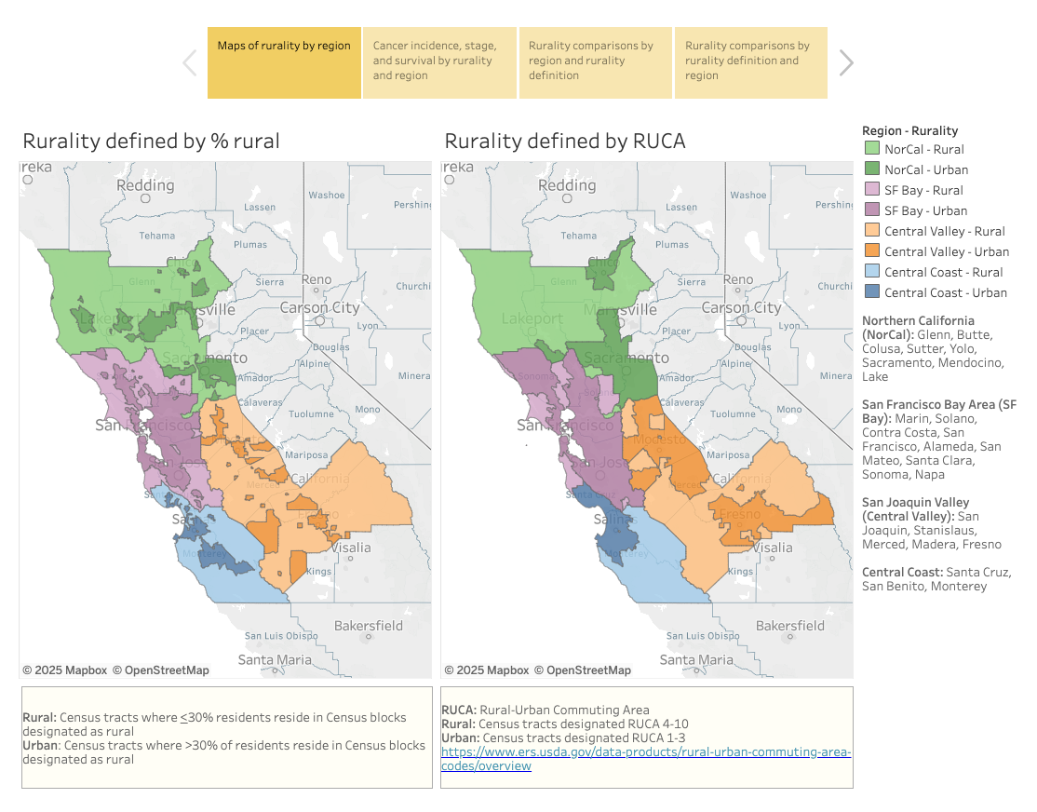

- Cancer incidence, stage, and survival by rurality and region

The second tab allows users to compare 5-year incidence rates, % late stage, and 5-year survival by rurality and region. Users can select measure, sex, and cancer site and explore the corresponding maps and tables. (Figure 2)

Figure 2. Rural Atlas view of cancer incidence, stage, and survival by rurality and region
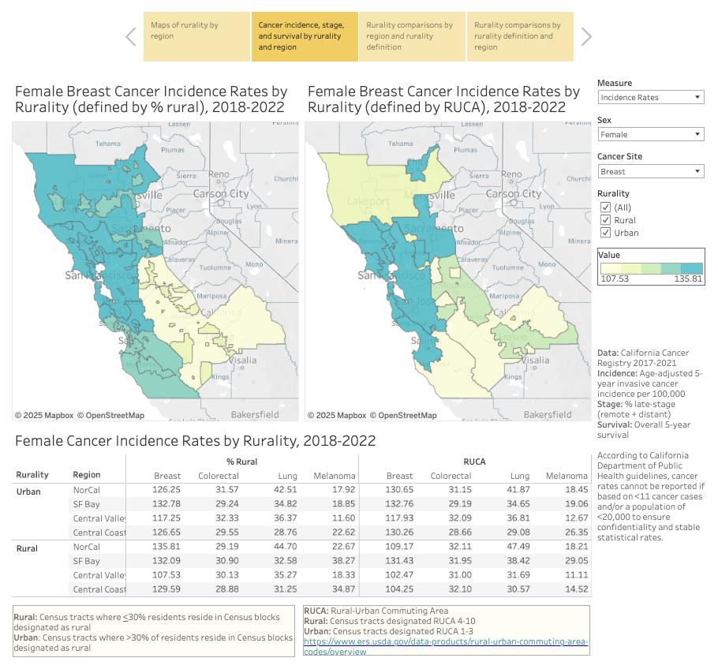

- Rurality comparisons by region and rurality definition
The third tab presents 5-year incidence rates, % late stage, and 5-year survival by rurality and region in dot plot form. Users can view differences between urban and rural areas across definitions of rurality. (Figure 3)

Figure 3. Rural Atlas view of rurality comparisons by region and rurality definition
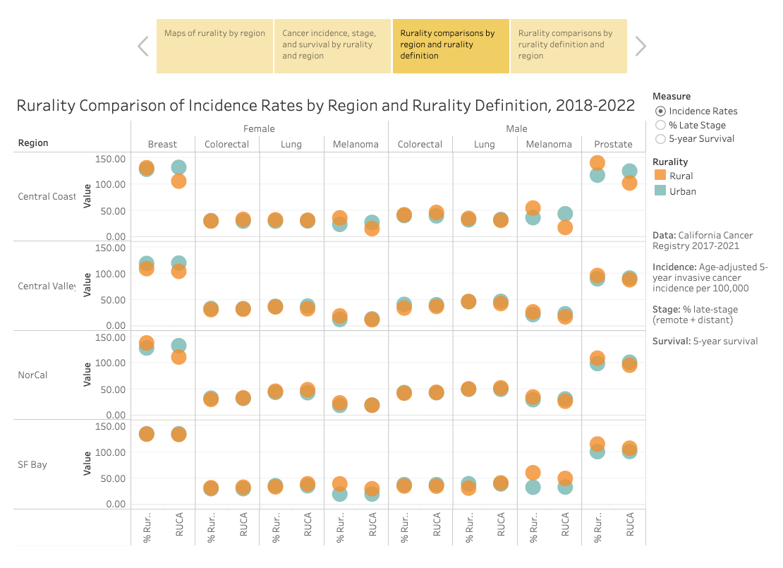

- Rurality comparisons by rurality definition and region
The final tab presents an alternative dot plot configuration that uses rurality definition for the rows and places all five regions side-by-side in each column to allow users to quickly compare rates across regions. (Figure 4)

Figure 4. Rural Atlas view of rurality comparisons by rurality definition and region
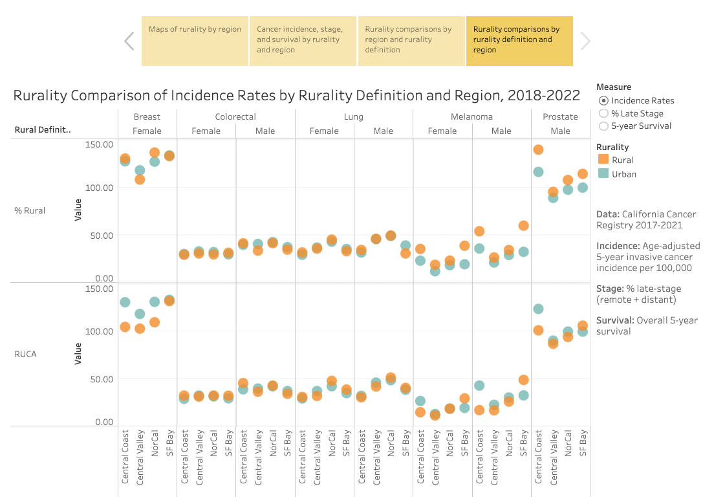

5. Rural Atlas highlights and conclusion

The Rural Atlas is intended to help better understand differences in cancer patterns across the rural–urban dichotomy in the HDFCCC Catchment area. We observed some regional differences between rural and urban areas:
- Incidence
  - Male prostate cancer incidence is lower in rural areas compared to urban areas in the Central Coast using the RUCA definition, but higher using the % rural definition.
  - Male and female melanoma incidence was higher in rural areas using the % rural definition, especially in the San Francisco Bay Area. Using the RUCA definitions, there were higher rates of melanoma only the San Francisco Bay Area and there were lower rates of melanoma in rural areas of the Central Coast.
- % Late Stage
  - Proportion of late-stage prostate cancer was higher in rural areas of the San Francisco Bay Area, especially when using the % rural definition.
- 5-year Survival
  - Male lung cancer survival was higher in rural areas using the % rural definition, but lower using the RUCA definition, especially in the Central Coast.

These observations highlight the complexity of analyzing data by rurality as outcomes are often dependent on how one defines rurality. Our hope is that in providing results for two different definitions of rurality, the Rural Atlas can be a flexible tool for informing local efforts for research and outreach programs for the HDFCCC.

PART 5: References

- Zahnd WE, James AS, Jenkins WD, et al. Rural-urban differences in cancer incidence and trends in the United States. Cancer Epidemiol Biomarkers Prev. 2018;27(11):1265-1274. doi:10.1158/1055-9965.EPI-17-0430.
- Franks JA, Davis ES, Bhatia S, et al. Defining rurality: an evaluation of rural definitions and the impact on survival estimates. J Natl Cancer Inst. 2023;115(5):530-538. doi:10.1093/jnci/djad031.
- Henley SJ, Anderson RN, Thomas CC, et al. Invasive cancer incidence, 2004–2013, and deaths, 2006–2015, in nonmetropolitan and metropolitan counties — United States. MMWR Surveill Summ. 2017;66(No. SS-14). doi: 10.15585/mmwr.ss6614a1.
- Oh DL, Schumacher K, Yang J, Wang K, Lin K, Gomez SL, Shariff-Marco S. Disparities in cancer incidence by rurality in California. JNCI. 2023;115(4):385-393. doi:10.1093/jnci/djac238.
- Oh DL, Wang K, Goldberg D, Schumacher K, Yang J, Lin K, Gomez SL, Shariff-Marco S. Disparities in cancer stage of diagnosis by rurality in California, 2015-2019. Cancer Epidemiol Biomarkers Prev. 2024;33(11):1523-1531. doi:10.1158/1055-9965.EPI-24-0564.
- Hofer B, Parikh-Patel A, Maguire F, Kizer K, Morris C, Movsisyan A. Rural-urban variations in cancer incidence, detection, and survival in California. [Internet]. Sacramento (CA): UC Davis Institute for Population Health Management; 2019 [cited 26 August 2025]. Available from: https://health.ucdavis.edu/media-resources/cancer/documents/pdfs/oph/RuralUrbanVariationsInCancerIncidenceDetectionSurvivalInCA.pdf
- Eberth JM, Zahnd WE, Adams SA, et al. Mortality-to-incidence ratios by US Congressional District: Implications for epidemiologic, dissemination and implementation research, and public health policy. Prev Med. 2019;129:105849. doi:10.1016/j,ypmed.2019.105849.
- Adams SA, Choi SK, Khang L, et al. Decreased cancer mortality-to-incidence ratios with increased accessibility of federally qualified health centers. J Community Health. 2015;40:633–641.
- National Cancer Institute. Surveillance, Epidemiology, and End Results Program — Cancer Statistics Explorer Network. [Internet]. Bethesda, MD: National Institutes of Health; 2025 [cited 23 September 2025]. Available from: https://seer.cancer.gov/statistics-network/explorer/
- McLafferty S, Wang F, Luo L, et al. Rural - urban inequalities in late-stage breast cancer: spatial and social dimensions of risk and access. Environ Plann B Plann Des. 2011;38:726–740.
- Mobley LR, Tangka FKL, Berkowitz Z, et al. Geographic disparities in late-stage breast cancer diagnosis rates and their persistence over time. J Womens Health. 2021;30:807–815.
- Long JC, Delamater PL, Holmes GM. Which definition of rurality should I use? The relative performance of 8 federal rural definitions in identifying rural-urban disparities. Med Care. 2021;59(10,Supp.5):S413-S419.
- Krutsinger DC, Yadav KN, Hart JL. Self-identified rurality in a nationally representative population in the US. Rural Remote Health. 2024;24:8483. doi:10.22605/RRH8483.
- Department of Health Care Services. Data De-identification Guidelines (DDG), Version 2.1. [Internet]. Sacramento, CA: California Department of Health Care Services; 2016 [cited 23 September 2025]. Available from: https://www.dhcs.ca.gov/dataandstats/Documents/DHCS-DDG-V2.1-010821%20(1).pdf
- Bureau of the Census. Urban area criteria for the 2010 Census. [Internet]. Washington, DC: Federal Register, vol.76, no.164; 24 August 2011 [cited 26 August 2025]. Available from: https://www.federalregister.gov/documents/2011/08/24/2011-21647/urban-area-criteria-for-the-2010-census
- USDA Economic Research Service. Rural-Urban Continuum Codes. [Internet]. Washington, DC: U.S. Department of Agriculture; 2025 [cited 26 August 2025]. Available from: https://www.ers.usda.gov/data-products/rural-urban-continuum-codes
- USDA Economic Research Service. Urban Influence Codes. [Internet]. Washington, DC: U.S. Department of Agriculture; 2025 [cited 26 August 2025]. Available from: https://www.ers.usda.gov/data-products/urban-influence-codes
- USDA Economic Research Service. Frontier and Remote Area Codes — Documentation. [Internet]. Washington, DC: U.S. Department of Agriculture; 2025 [cited 26 August 2025]. Available from: https://www.ers.usda.gov/data-products/frontier-and-remote-area-codes/documentation
- USDA Economic Research Service. Rural-Urban Commuting Area Codes. [Internet]. Washington, DC: U.S. Department of Agriculture; 2025 [cited 26 August 2025]. Available from: https://www.ers.usda.gov/data-products/rural-urban-commuting-area-codes
- Health Resources & Services Administration. How we define rural. [Internet]. Rockville, MD: Health Resources & Services Administration; 2025 [cited 26 August 2025]. Available from: https://www.hrsa.gov/rural-health/about-us/what-is-rural
- US Census Bureau. 2010 Census Urban and Rural Classification and Urban Area Criteria. [Internet] Washington, DC: US Census Bureau; 2021 [cited 19 September 2025]. Available from: https://www.census.gov/programs-surveys/geography/guidance/geo-areas/urban-rural/2010-urban-rural.html
- USDA Economic Research Service. Rural-Urban Commuting Area Codes - Users’ Guide. [Internet] Washington, DC: U.S. Department of Agriculture; 2025 [cited 19 September 2025]. Available from: https://www.ers.usda.gov/data-products/rural-urban-commuting-area-codes/users-guide
- Census Office. California Regions Map. [Internet]. Sacramento, CA: California Census Office; 2025 [cited 15 September 2025]. Available from: https://census.ca.gov/regions/
- UCSF Health Atlas. [Internet]. San Francisco, CA: University of California; 2025 [cited 15 September 2025]. Available from: https://healthatlas.ucsf.edu
- Surveillance, Epidemiology, and End Results (SEER) Program. U.S. Census Tract Population Data. [Internet]. Bethesda, MD: National Cancer Institute; 2025 [cited 23 September 2025]. Available from: https://seer.cancer.gov/censustract-pops/

